Design Patterns in Java

What are Design Patterns?
Design Patterns are well-proved solution for solving the specific problem/task.

FACTORY METHOD:
Category: Creational Design Pattern.
The factory design pattern says that define an interface (A java interface or an abstract class) and let the subclasses decide which object to instantiate.
The factory method in the interface lets a class defer the instantiation to one or more concrete subclasses.
If we notice the name ‘Factory method’, that means there is a method which is a factory of objects.

How to implement Factory Method Design Pattern?
- Create an Interface.
- Create concrete class implementations of the same interface.
- Create a Factory to generate object of concrete class based on given information.
- Use the Factory to get object of concrete class by passing an information such as type.

Example shown in UML diagram below for a notification service.
Explanation:
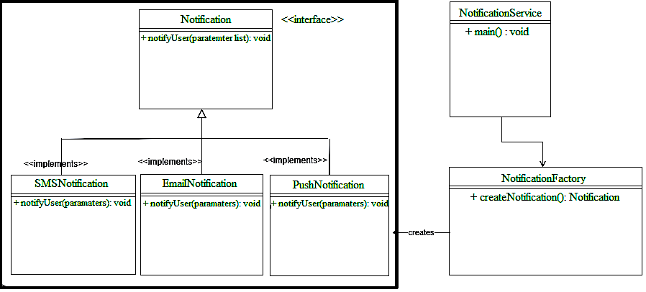
There is an interface called Notification, and 3 concrete classes are implementing Notification interface. A factory class NotificationFactory is created to get a Notification object.

ABSTRACT FACTORY:
Category: Creational Design Pattern.
Abstract Factory “provides an interface for creating families of related or dependent objects without specifying their concrete classes”.
In other words, this model allows us to create objects that follow a general pattern.
Abstract Factory pattern is almost similar to Factory Pattern is considered as another layer of abstraction over factory pattern. Abstract Factory patterns work around a super-factory which creates other factories.

How to implement Abstract Factory Design Pattern?
- Create an Interface.
- Create concrete class implementations of the same interface.
- Create a Factory to generate object of concrete class based on given information.
- Use the Factory to get object of concrete class by passing an information such as type.
- Declare the abstract factory interface with a set of creation methods for all abstract families or objects.
- Make concrete classes implement this interface.
- Create a Factory Provider to provide abstract object-family factory based on client requirement.

Example shown in UML diagram below for Abstract factory for Animal and Color families.
Explanation:
There is an interface called AbstractFactory, and 2 concrete classes are implementing AbstractFactory interface. A factory class FactoryProvider is created to get an object factory (AnimalFactory or ColorFactory) and recursively a type of object from that family.

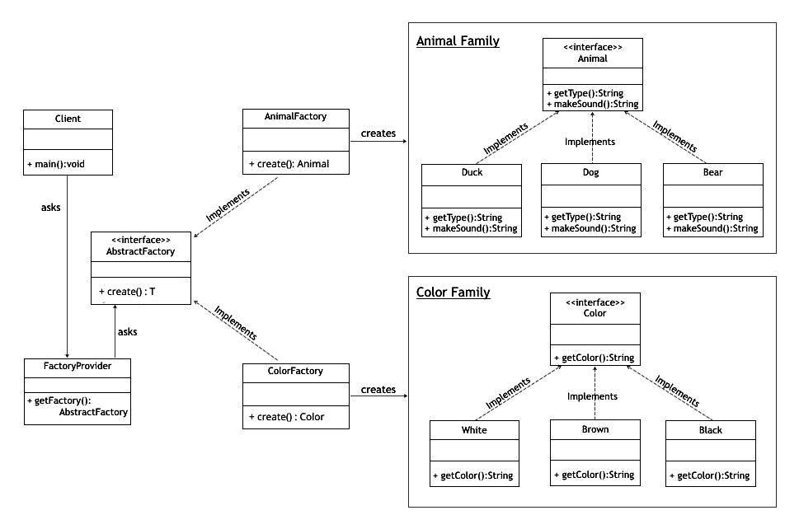
Note:
The Factory Method is just a method. It can be overridden in a subclass. Abstract Factory is an object. It has multiple factory methods on it.
The Factory Method pattern uses inheritance and relies on a subclass to handle the desired object instantiation.

SINGLETON:
Category: Creational Design Pattern.
Singleton Design Pattern ensures that a class has only one instance, while providing a global access point to this instance.

There are 2 forms of Singleton Design Pattern:
Early Instantiation: creation of instance at load time.
Lazy Instantiation: creation of instance when required.

How to implement a Singleton Design Pattern?
- Add a private static field to the class for storing the singleton instance.
- Declare a public static creation method for getting the singleton instance.
- Implement “lazy initialization” inside the static method. It should create a new object on its first call and put it into the static field. The method should always return that instance on all subsequent calls.
- Make the constructor of the class private. The static method of the class will still be able to call the constructor, but not the other objects.
- Go over the client code and replace all direct calls to the singleton’s constructor with calls to its static creation method.

Example shown in UML diagram on the right here for JDBC Connection Singleton object.

Explanation:
- There is a class called JDBCSingleton. This JDBCSingleton class contains its constructor as private and a private static instance ‘jdbc’ of itself.
- JDBCSingleton class provides a static method ‘getInstance()’ to get its static instance to the outside world. Now, JDBCSingletonDemo class will use JDBCSingleton class to get the JDBCSingleton object.

PROTOTYPE:
Category: Creational Design Pattern.
Prototype Design Pattern lets you copy existing objects without making your code dependent on their classes.

Note:
This pattern should be followed, if the cost of creating a new object is expensive and resource intensive.

How does it work?
You create a set of objects, configured in various ways. When you need an object like the one you’ve configured, you just clone a prototype instead of constructing a new object from scratch.

How to implement Prototype Design Pattern?
Create a prototype interface with a cloning method.
Create Concrete classes that implement the prototype interface, hence implementing the cloning method as well.
Optional: You can create a factory class defining types of Prototypes available in a static Map and a static method to get the Prototype clone based on prototype type.

Example shown in UML diagram below for Prototype factory for Album, Movie and Show types.
Explanation:
There is an interface called PrototypeCapable, and 3 concrete classes are implementing PrototypeCapable interface.
A factory class PrototypeFactory is created to get a clone of object (Album or Movie or Show).
There is an enum ObjectType (ALBUM, MOVIE, SHOW).
PrototypeFactory has a private static field of ObjectType type and getInstance(ObjectType objType) method to get clone of required Object type.
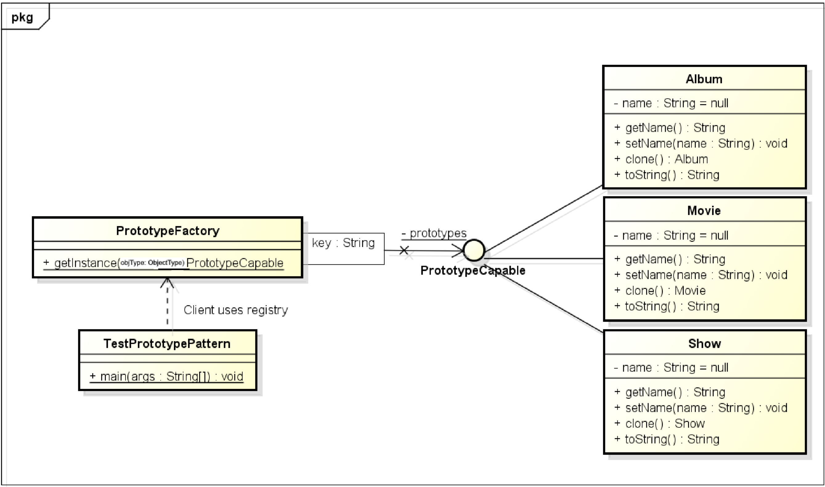
TEMPLATE METHOD:
Category: Behavioural Design Pattern.
It defines the skeleton of an algorithm in the superclass but lets subclasses override specific steps of the algorithm without changing its structure.
How to implement Singleton Design Pattern?
- Analyze the target algorithm to break it into steps that are common to all subclasses and which ones will always be unique.
- Create the abstract base class and declare the final template method and a set of abstract methods representing the algorithm’s steps.
- Outline the algorithm’s structure in the template method by executing corresponding steps.
- It’s okay if all the steps end up being abstract. However, some steps might benefit from having a default implementation. Subclasses don’t have to implement those methods.
- For each variation of the algorithm, create a new concrete subclass. It must implement all of the abstract steps, but may also override some of the optional ones.

Example shown in UML diagram below for Singleton Design Pattern for a game and some of the common steps/operations included in a game.
Explanation:
We are going to create a Game abstract class defining operations with a template method set to be final so that it cannot be overridden. Cricket and Football are concrete classes that extend Game and override its methods.
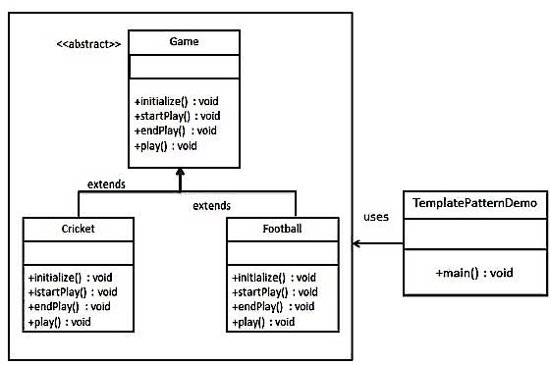
TemplatePatternDemo, the demo class, will use Game to demonstrate use of template pattern.

BUILDER:
Category: Creational Design Pattern.
This Design Pattern lets you construct complex objects step by step. The pattern allows you to produce different types and representations of an object using the same construction code.

How to implement Builder Design Pattern?
- Declare the common construction steps for building all available product representations in the base builder interface.
- Create a concrete builder class for each of the product representations and implement their construction steps.
- Implement a method for fetching the result of the construction. Note: The reason why this method can’t be declared inside the builder interface is that various builders may construct products that don’t have a common interface. Therefore, you don’t know what would be the return type for such a method. However, if you’re dealing with products from a single hierarchy, the fetching method can be safely added to the base interface.)
- Optional: Create a director class. It may encapsulate various ways to construct a product using the same builder object.
- The client code creates both the builder and the director objects. Before construction starts, the client must pass a builder object to the director.
- The construction result can be obtained directly from the director only if all products follow the same interface. Otherwise, the client should fetch the result from the builder.

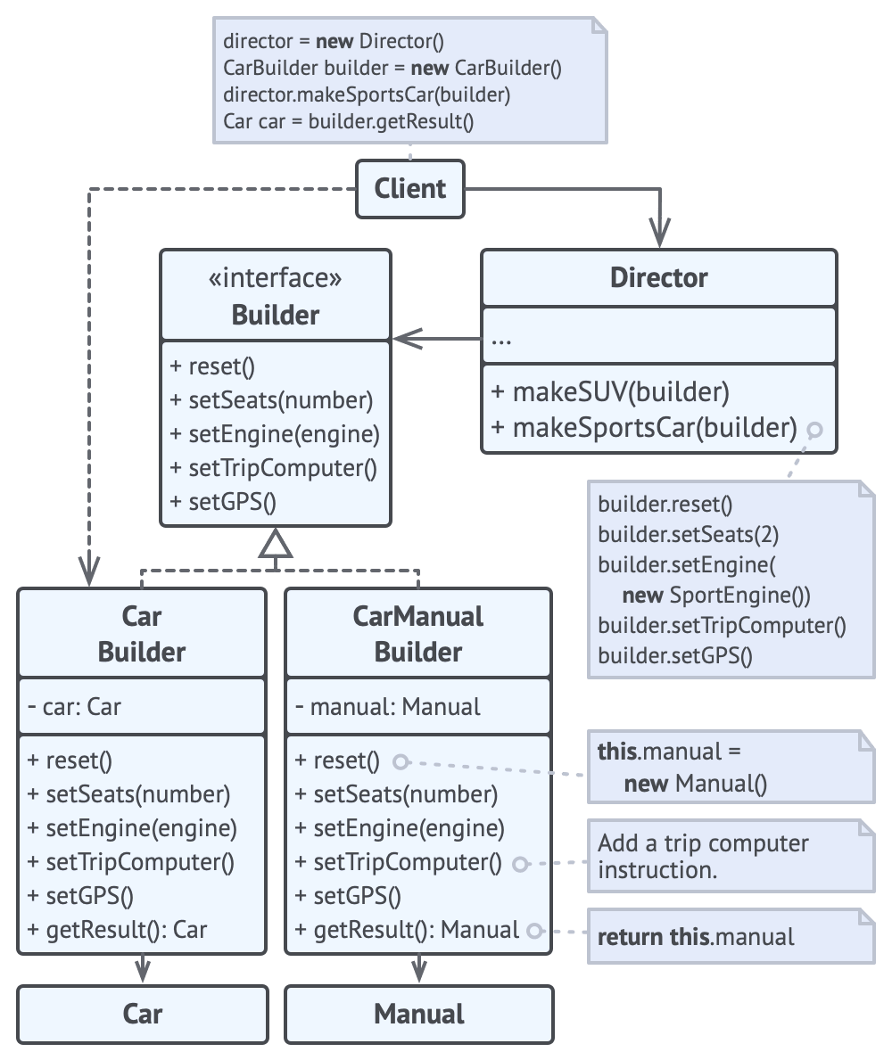
Example shown in UML diagram on the right for Builder Design Pattern for different types of products
Explanation:
- Create a Builder interface and declare steps as methods for creation of complex objects for a Car and CarManual.
- Create the concrete classes CarBuilder and CarManualBuilder.
- Declare an instances of own type and implement the Builder methods.
- Implement any other methods required for building object specific to the type (non-common step method).
- Define a method getResult() that returns the Object for the type referred and reset() method to reset the object state.
- Create a Director class with methods for building various types accepting corresponding Builder instances.
- Client will have instances of builders and Director. Client can delegate task of building objects to the Director class.
PROXY:
Category: Structural Design Pattern.
This Design Pattern lets you provide a substitute or placeholder for another object. A proxy controls access to the original object, allowing you to perform something either before or after the request gets through to the original object.
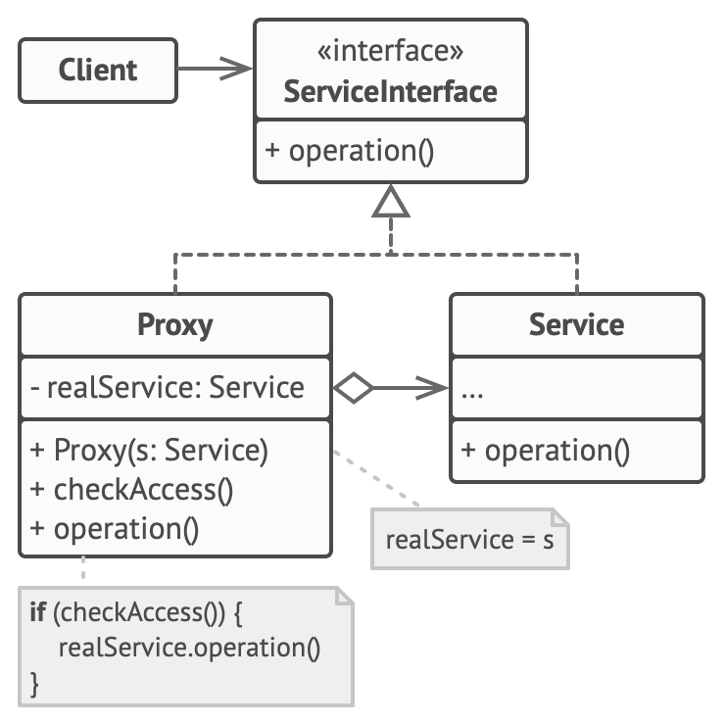
The Proxy pattern suggests that you create a new proxy class with the same interface as an original service object. Then you update your app so that it passes the proxy object to all of the original object’s clients. Upon receiving a request from a client, the proxy creates a real service object and delegates all the work to it.
How does it work?
The Service Interface declares the interface of the Service. The proxy must follow this interface to be able to disguise itself as a service object.
The Service is a class that provides some useful business logic.
The Proxy class has a reference field that points to a service object. After the proxy finishes its processing (e.g., lazy initialization, logging, access control, caching, etc.), it passes the request to the service object.

How to implement Proxy Design Pattern?
Create an interface for original class.
Create the original class that implements this interface.
Create a proxy class implementing same interface with reference field to original class.
Declare (if any) proxy specific methods (for pre and/or post operations on object).
Client has access to proxy class that in-turn calls original class when and where required.

Example shown in UML diagram on the right for a third-party YouTube integration library.
Explanation:
The library provides us with the video downloading class. However, it’s very inefficient. If the client application requests the same video multiple times, the library just downloads it over and over.
The proxy class implements the same interface as the original downloader and delegates it all the work. However, it keeps track of the downloaded files and returns the cached result when the app requests the same video multiple times.
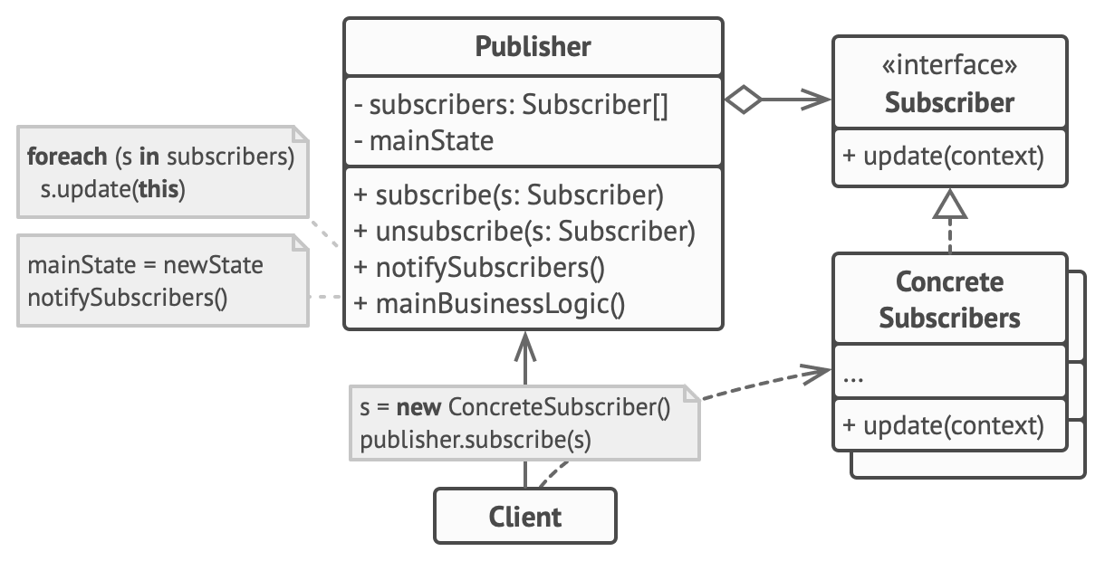
OBSERVER:
Category: Behavioural Design Pattern.
This Design Pattern lets you define a subscription mechanism to notify multiple objects about any events that happen to the object they’re observing.

How to implement Observer Design Pattern?
- Declare the subscriber interface. At a bare minimum, it should declare a single update method.
- Declare the publisher interface and describe methods for adding a subscriber object to and removing it from the list.
- Create concrete publisher classes. Each time something important happens inside a publisher, it must notify all its subscribers.
- Implement the update notification methods in concrete subscriber classes. Most subscribers would need some context data about the event. It can be passed as an argument of the notification method.

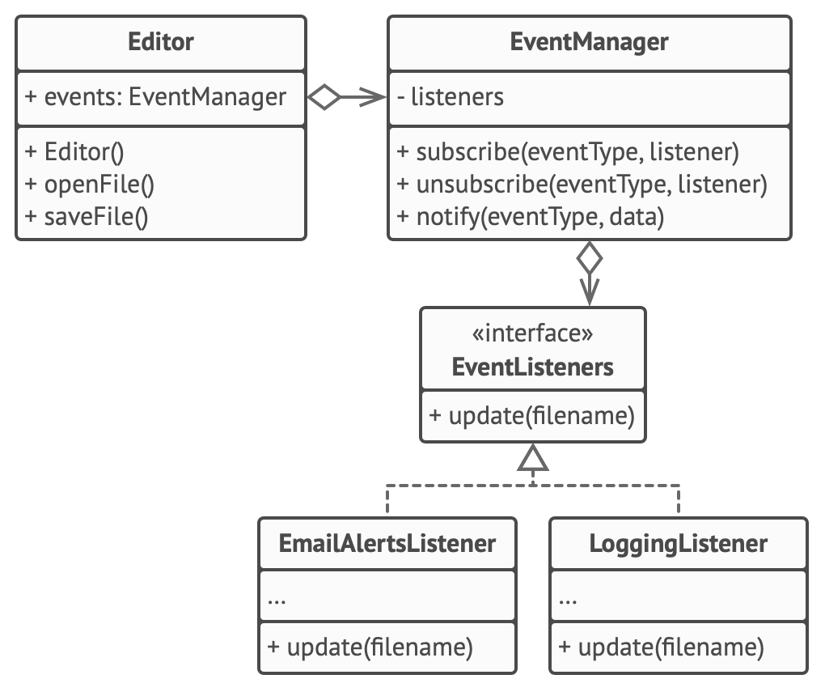
Example shown in UML on the right for Observer Design Pattern for text editor object to notify other service objects about changes in state.
Explanation:
- In this implementation, the editor class doesn’t maintain the subscription list by itself. It delegates this job to the special helper object EventManager devoted to just that. (This helper class can be upgraded to serve as a centralized event dispatcher, letting any object act as a publisher).
- Create an event listener interface and various event listeners to implement it (EmailAlertsListener and LoggingListener implements EventListeners).
- Create EventManager class with a map of event types and their listeners.
- Create methods subscribe, unsubscribe and notify in EventManager.
- Create Editor class with a field of EventManager type for various events and create methods for Editor related operations. (Editor operations’ methods will have the call to notify method of EventManager).
- Client can use editor’s object to access subscribe or unsubscribe to events.

